Communication System
The basic structure of a digital communication system is shown which represents the architecture of the communication systems in use today. Within the transmitter of such a communication system the following tasks are carried out:
● source encoding,
● channel encoding,
● modulation.

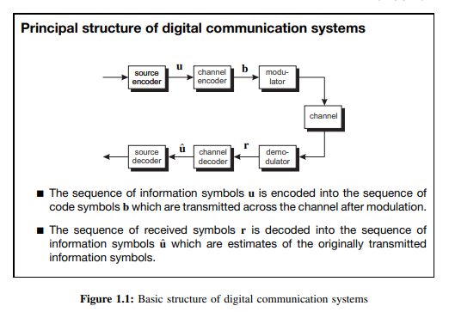
In the receiver the corresponding inverse operations are implemented: ● demodulation, ● channel decoding, ● source decoding. According to Figure 1.1 the modulator generates the signal that is used to transmit the sequence of symbols b across the channel. Due to the noisy nature of the channel, the transmitted signal is disturbed.
The noisy received signal is demodulated by the demodulator in the receiver, leading to the sequence of received symbols r. Since the received symbol sequence r usually differs from the transmitted symbol sequence b, a channel code is used such that the receiver is able to detect or even correct errors. To this end, the channel encoder introduces redundancy into the information sequence u. This redundancy can be exploited by the channel decoder for error detection or error correction by estimating the transmitted symbol sequence uˆ. In his fundamental work, Shannon showed that it is theoretically possible to realise an information transmission system with as small an error probability as required (Shannon, 1948). The prerequisite for this is that the information rate of the information source be smaller than the so-called channel capacity. In order to reduce the information rate, source coding schemes are used which are implemented by the source encoder in the transmitter and the source decoder in the receiver.

